The Harvester :

**\*\*\*t Command: the Harvester -d** [**www.zoho.com**](http://www.zoho.com/) **-l 300 -b all :-**

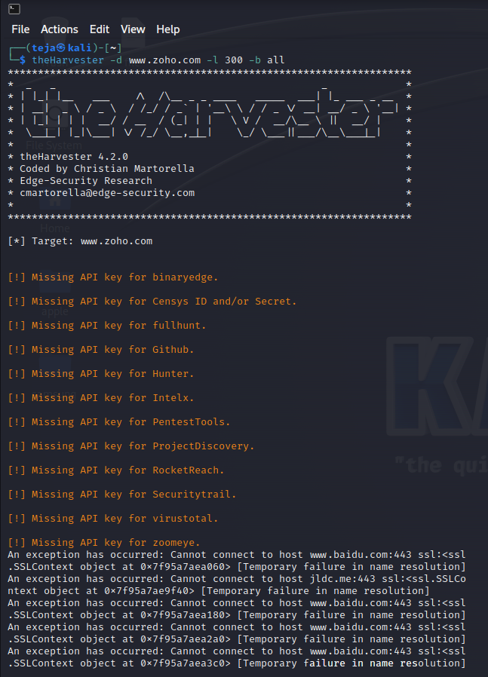

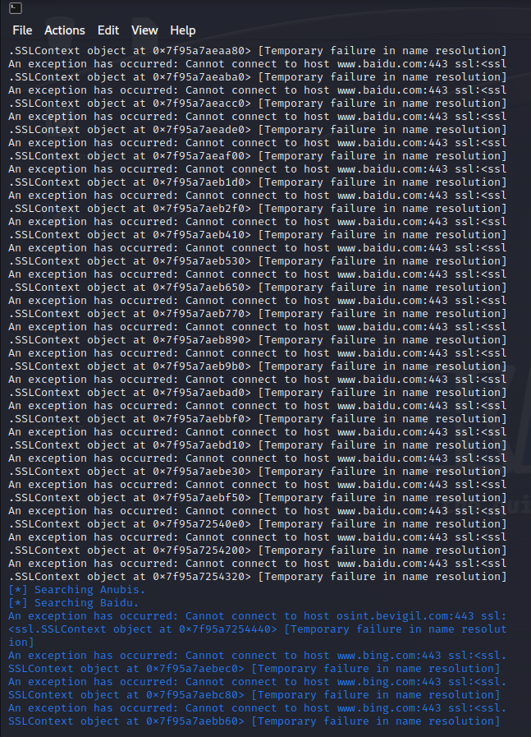

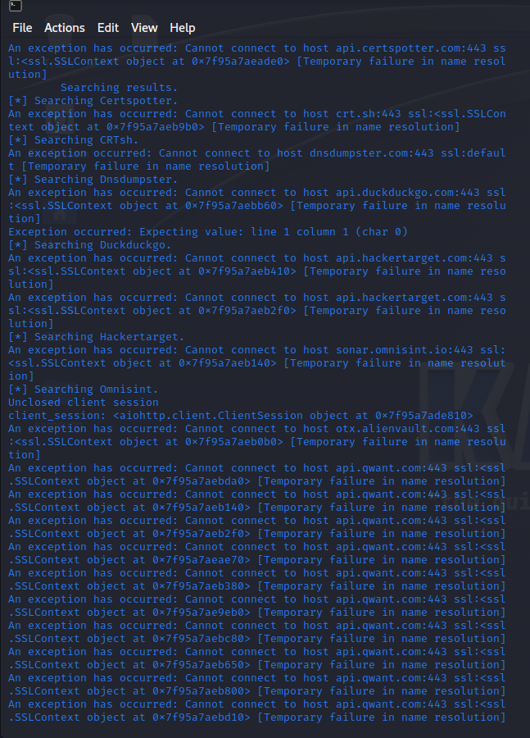

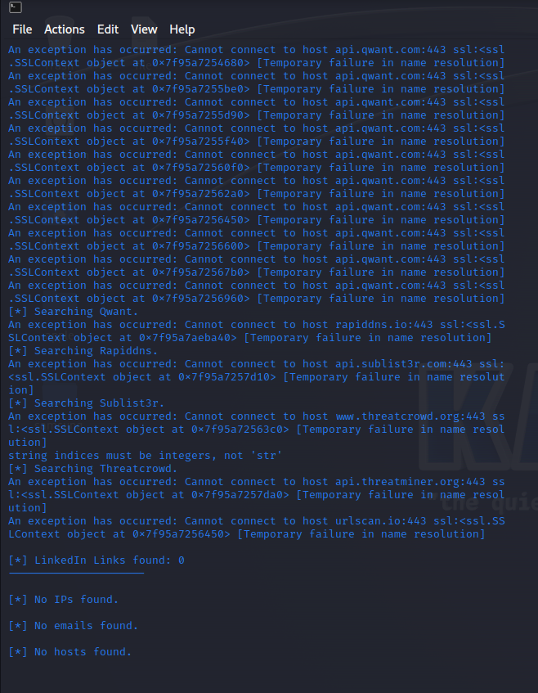

“**theHarvester -d** [**www.zoho.com**](http://www.zoho.com/) **-l 300 -b all -f test” :**

